CHAPTER ONE
INTRODUCTION
1.1 BACKGROUND OF STUDY
Among different toxic substances, heavy metals are the most dangerous to the environment. It has been reported that the toxicity due to metallic discharge annually into the environment far exceeds the combined total toxicity of all radioactive and organic waste (Badmus et al., 2007). Heavy metals are commonly found in aqueous wastewaters of many industries such as paints, batteries, ceramic glazes, pigments, dyes, glass, ink, match and firework and metal products (Meena et al., 2005). These heavy metals are usually toxic at certain concentrations to living organisms, persistent in nature, non-biodegradable and tend to accumulate in the food chain (Ahluwalia and Goyal, 2007). It is therefore necessary to remove these metals before their discharge into receiving water bodies.
Nickel is a non-biodegradable toxic heavy metal, which is ubiquitous in wastewater bodies in various proportions (Amin et al., 2021). The main origin of nickel pollution in water is from industrial processes such as galvanization, smelting mining, dyeing operation, battery manufacturing and metal finishing (Olugbenga et al., 2014). Trace amounts of nickel are beneficial to human life as enzyme activators. Above permissible concentrations (toxic limits) of nickel is 0.1mg/m³(WHO). Different types of diseases such as lung cancer, renal edema, dermatitis and gastrointestinal disorder may be caused by traces of nickel (Mervette and Abdel-Moneim, 2014). Conventional methods for nickel (II) removal from wastewater include chemical oxidation or reduction, chemical precipitation, ion exchange, membrane separation, filtration, electrochemical treatment and adsorption (Liakos et al., 2021). These techniques which are economically expensive suffer from incomplete metal removal, generation of metal sludge and other disposable waste products (Kinhikar, 2012). Adsorption techniques using organic, inorganic, natural, synthetic, activated or modified adsorbents are the most widely employed procedures in wastewater treatment and constitute low-cost alternatives. From the literature survey, potential low-cost adsorbents (activated or not) for heavy metal removal include: Rice husk, suagarcane bagasse pith, cococnut husk, date stones, teak tree bark, palm fruit seeds, exhausted olive cake, coconut leaves, ion exchange resins, industrial wastes, fruit wastes, petroleum wastes and fertilizer wastes (Ali et al., 2012).
Activated carbon is obtained through either physical or chemical activation procedures and is characterized by a large surface area, high adsorption capacity, high yields, porous structure, selective adsorption and high purity but quite expensive which calls for search for alternative adsorbents to replace it (Aajish, 2014). During the chemical activation process, reagents such as inorganic salts (ZnCl₂, FeCl₃, KHCO₃, MgCl₂), acids (HNO₃, H₃PO₄, H₂SO₄) or soluble bases (KOH, NaOH) are often used (Mohammad and Bahreini, 2010). These chemical agents favour the dehydration of materials and allow for the development of micropores (Sugumaran et al., 2012).
This present work investigated the use of low-cost adsorbent obtained from the seed shells of Cassava modified with acid for heavy metal removal from aqueous solution in batch systems. The sorption isotherm, kinetics of sorption and influence of initial metal ion concentration, contact time, temperature and pH were also investigated.

1.2 AIM AND OBJECTIVES
1.2.1 AIM OF STUDY
This work involves the production and performance evaluation of Acid Modified Cassava Seed Shell (AMCSS) for the removal of Ni²⁺ from its aqueous solution.
1.2.2 SPECIFIC OBJECTIVES OF STUDY
The specific objectives of this work includes:
- Characterization of AMCSS using Fourier Transform Infrared Spectroscopy (FT-IR), Thermal Gravimetric Analysis (TGA), Scanning Electron Microscopy (SEM) and Branauer-Emmeth-Teller Analysis (BET).
- Determination of the influence of experimental parameters such as contact time, initial concentration, temperature and pH on the adsorption capacity of the adsorbent.
- Evaluation of the equilibrium isotherm data by the application of the Langmuir, Freundlich, Flory-Huggins, Dubinin-Radushkevich and Temkin isotherm model.
- Determination of the kinetics of the adsorption of the Ni²⁺ ion onto the adsorbent. Determination of the Thermodynamic Parameters on the adsorption of Ni²⁺ on AMCSS.
1.3 JUSTIFICATION AND SIGNIFICANCE OF THE STUDY
The rapid increase in the world population in the last 100 years and the vast industrial revolution has spiked the demand for fresh water and waste water production. Due to the fact that the demand for fresh water is higher than supply, there is need therefore, for special treatment to obtain water of good quality and environmentally less hazardous effluents (Orjoke et al., 2015).
Research has it that many of the technologies for the removal of heavy metals from wastewater such as electroplating, membrane separation, electro kinetics, etc are expensive and many of which are problematic as a result of associated limitations such as poor removal efficiency, unavailability, accumulation of large secondary waste and so on. The quest for a more benign environment for all by removing hazardous heavy metal from the environment has necessitated for a new sustainable and eco-friendly adsorbent like AMCSS. Therefore, from economic and efficiency stand point, adsorption method using low cost adsorbent for the removal of heavy metals is regarded as the most promising and widely used (Fouroutan, 2019).
This research is part of the process of developing an alternative adsorbent that is cheap, effective and available for the removal of Nickel (II) ions from aqueous solutions.

CHAPTER TWO
LITERATURE REVIEW
This chapter reviews different works that have been done using adsorbents for the removal of metals or other contaminants from places that are not needed. A lot of works have been done in this area and some of these are presented in the following paragraphs.
A novel biosorbent, modified Casia siberian seed husk was explored by Eze et al., (2021) for its potential in removing Pb²⁺ from aqueous solution. The biosorbent was prepared by pulverizing the husk, oven dried for an hour at 110^{ᵒ}C. The ground husk was modified at 550^{ᵒ}C and then activated with NaOH and H₃PO₄ to get four different adsorbents. The adsorbents were characterized with FT-IR, TGA and SEM. The FT-IR results showed that there were new functional groups as a result of the activation/modification with heat, NaOH and H₃PO₄. The TGA revealed that the modified CSSH biosorbents were thermally stable up to 400^{ᵒ}C, while the unmodified CSSH is only thermally stable up to 40-45^{ᵒ}C, indicating the differences in the thermal stability. The TGA also revealed that the thermal decomposition of the adsorbents took place in three stages with significant mass losses. The SEM image showed that modified CSSH possessed the right percentage of carbon content to be used in adsorbent synthesis (>74%). It also showed that the outer surface of the adsorbents were rough and discontinuous in their formation which cannot be considered as pores but connecting channels to the interior of the adsorbent. This is summarized to be interpenetrated by different pore sizes. It was observed that the ground CSSH and thermally modified CSSH adsorbent fitted into Temkin isotherm model indicating that free energy of sorption is a function of surface coverage whereas the NaOH and H₃PO₄ modified CSSH fitted into the Freundlich isotherm model indicating multilayer Pb²⁺ binding mechanism onto the adsorbents. Performance evaluation of the adsorbents revealed that they are capable of removing Pb²⁺ ions from aqueous solution efficiently.
Akinhanmi, et al., (2020) studied the kinetic, equilibrium, thermodynamics and optimization evaluations of the biosorption of Cd²⁺ ion on orange peel (OP) using various physicochemical parameters for the metal ion such as temperature, contact time, sorbent dosage, pH and initial adsorbate concentration. The surface properties of the orange peel powder were studied using SEM, XRD and FT-IR. The utmost uptake of Cd(II) ion was obtained at a contact time of 120mins, initial metal concentration of 240mg/L, adsorbent dosage of 0.04g/L, temperature of 45^{ᵒ}C and solution pH of 5.5. Equilibrium results showed that the orange peel (OP) adsorbent had an adsorption capacity of 128.23mg/g as obtained from the Langmuir isotherm. The adsorption kinetics data followed a pseudo-first order kinetic model with correlation coefficient (R²) > 0.9 and low standard % error values. The adsorption process was found to be endothermic in nature with enthalpy of 0.0046KJmol⁻¹ and entropy of -636.865Jmol⁻¹K⁻¹. Results from the optimization study indicated that higher adsorbent dosage and lower Cd(II) ion concentration increased the percentage of Cd(II) ion removal. Thus, orange peel could be used in the removal of Cd(II) ion from aqueous solutions.
David, et al., (2020) used thermal as well as alkaline modified kaolin for the adsorptive removal of lead(II) ion from aqueous solution. The raw and modified kaolin samples were characterized using Brunauer-Emmett-Telller nitrogen adsorption surface area analysis, X-ray diffraction, Fourier-transform infrared spectroscopy and Scanning electron microscopy techniques. The effectiveness of the modified kaolin for the removal of lead(II) ions from aqueous solution was studied and compared to that of the raw kaolin sample. The results showed that the surface area of the modified samples increased from 19.170m2/g to 247.889m2/g, 208.745m2/g and 221.608m²/g, followed by an increase in the pore volume for the modified samples. However, the modification led to a weak alteration to the kaolin structure. Residual ions detected by atomic absorption spectroscopy showed that the modified kaolin samples have improved removal efficiency for Pb(II) (83%, 88%, 85%) when compared to the raw sample (33%). The adsorption capacities of the raw kaolin and modified kaolin were observed to increase with increase in contact time, initial metal ion concentration and adsorbent dose. The adsorption of Pb(II) unto the raw and modified kaolin followed Freundlich (R² = 0.9937) and Langmuir (R² = 0.9837) adsorption isotherm models respectively. The modified kaolin efficiently eliminated Pb(II) ion from aqueous solution.
The equilibrium adsorption isotherms of Cd(II), Pb(II) and Zn(II) ions, detoxification from waste water using unmodified and EDTA-modified maize husk was studied by Igwe and Abia, 2007. The amount of the metal ions adsorbed increased as the initial concentration increased. Also, the EDTA modification enhanced the adsorption capacity of the maize husk due to the chelating ability of the EDTA(Ethylenediamine Tetra Acetic acid). Among the three adsorption isotherms studied, Dubinin-Radushkevich isotherm gave the best fit with R² value ranging from 0.7646 to 0.9988 and an average value of 0.9321. The sorption process was known to be a physisorption process.
Akpomie and Dawodu (2014) described the study of alkaline activation of a montmorillonite as a low cost adsorbent for the simultaneous removal of Ni(II) and Mn(II) ions from solution. The experiment was performed using batch adsorption to evaluate the effect of pH, initial metal ion concentration, particle size, adsorbent dosage, contact time and temperature on adsorption. Alkaline modification of the montmorillonite was found to increase the specific surface area from 23.2 to 30.7m2/g and the cation exchange capacity from 90.78 to 94.32meq/100g. The adsorption capacity of the montmorillonite for Ni(II) and Mn(II) ions was found to increase with alkaline modification. FT-IR, XRD and SEM analysis were used to characterize the adsorbent. Four isotherms namely: the Langmuir, Freundlich, Temkin and Dubinin-Radushkevich models were applied to the experimental data and the best fit was obtained by the Freundlich model. The Pseudo-first order, Pseudo-second order, Elovich and intraparticle diffusion rate equations were utilized to analyze the kinetic data, which showed a greater conformity with the Elovich equation. Thermodynamic studies revealed a spontaneous, endothermic and physical adsorption process.
Ejikeme, et al., (2011) worked on the application of Gambeya albida seed shell as an alternative adsorbent for the removal of lead(II) and copper(II) ion from simulated waste water. The batch adsorption was investigated using activated carbon produced from the seed shell. Pseudo-first order, Pseudo-second order, Bhattacharya-Venkobachar, Elovich and Intra-particle and film diffusion kinetic models were employed to carry out kinetic analysis of the adsorption processes. Langmuir, Freundlich and Temkin models were used for isotherm studies. Adsorption of both metal ions was found to increase with an increase in the initial metal concentration and contact time. The rates of adsorption processes were controlled by film (boundary layer) diffusion. Langmuir isotherm best described the adsorption processes and monolayer adsorption capabilities were found to be 16.67 and 18.52mg.g⁻¹ for copper(II) and lead(II) ions respectively.
El-Said et al, (2018) investigated the adsorption of Zn(II), Cd(II) and Hg(II) ions on rice husk ash (RHA) in single, binary and tertiary systems. Batch experiments were carried out for mono- and multi-component systems with varying metal ion concentration (mg/L) to investigate the competitive adsorption characteristics. The scanning electron micrographs (SEM) of the rice husk ash surfaces before and after the adsorbent were equilibrated with the metal ion solution clearly established the presence of the metal ions and some surface modifications.
Hoyos-Sanchez, et al., (2017) used chemically and thermally treated Rice husk (RH) for the removal of Cd(II) ions from aqueous solution. The rice husk was treated with HCl and NaOH, then, thermal treatments to 300, 500 and 700^{ᵒ}C were applied. The chemical composition and morphological characteristics of RH were evaluated by different techniques. The specific surface area analysis of RH samples by BET nitrogen adsorption method provided specific surface areas ranging from 6 to 14m²/g. SEM, FTIR and EDX analyses of RH were carried out to determine the surface morphology, functional groups involved in metal binding mechanism and C/O and C/Si ratios respectively. The maximum Cd(II) adsorption capacity was 28.27mg/g at an optimum pH of 6.0. The kinetic studies revealed that adsorption process followed the Pseudo-second order kinetic model.
Dalia, et al., (2012) studied the use of cross-linked polyethylenimine (CPEI) as an adsorbent for abstraction of uranium ions from wastewaters. The CPEI was phosphonated by phosphoric acid for the selective removal of the uranium ions. The binding affinity of the phosphonated cross-linked polyethlenimine (PCPEI) to uranium ions was assessed as well as its ability to be regenerated for reuse. It exhibited high removal percentage for uranium ions up to 99% with high selectivity even in the presence of competing ions (Mn, Ni, As). The Freundlich isotherm was found to be the best fit describing the adsorption process of uranyl ions onto the PCPEI. The Pseudo-second order equation was found to better explain the adsorption kinetics, implying chemisorptions. The thermodynamic study of the adsorption revealed high activation energies which confirmed the chemisorptions as the mechanism of adsorption.
Akpomie, et al., (2017) looked at the potential of novel Cassava peel Modified Kaolinite Clay for the enhanced sorption of trivalent chromium ions. The adsorption capacity of the Unmodified Kaolinite Clay (UKC), Cassava peel Modified Kaolinite Clay (CPMKC) and Unmodified Cassava peel Modified Kaolinite Clay (UCPMKC) were compared. The effect of experimental variables such as pH, Cr(III) ions concentration, adsorbent dosage, particle size, agitation time and temperature on sorption was studied using batch methodology. Equilibrium isotherm studies was analyzed by the Langmuir, Freundlich and Halsey isotherm models while the Pseudo-first order (PFO), Pseudo-second order (PSO) and intraparticle diffusion (IPD) models were used for kinetic analyses. All the experimental variables were found to have significant effect on Cr(III) ions sorption on the adsorbents with an optimum pH of 5.0, adsorbent dose 0.1g, particle size 100µm and chromium concentration of 375mg/L obtained. Equilibrium sorption at 25, 20 and 60min was obtained for UKC, CPMKC and UCP respectively which showed the faster sorption potential of CPMKC. The Langmuir model had the best fit with linear regression (R²) OF 0.991 and 0.998 for UKC and UCP. The Freundlich and Halsey models gave the best fit with same R2 of 0.975 for CPMKC and the Sum of Square of Errors (SSE) was slightly lower for the Freundlich (0.833) than the Halsey (0.897). The PFO model gave the best fit (R²> 0.980) and lowest SSE than the PSO model. An initial sorption rate h (mg/gmin) of 2.16, 3.14 and 1.02 was obtained for UKC, CPMKC and UCP respectively. Thermodynamics revealed an endothermic physical sorption of Cr(III) on all the adsorbents. The sorption was in the order UCP >CPMKC >UKC, which showed the suitability of cassava peel in enhancing the sorption ability of kaolinite for chromium ion from aqueous solution.
Arunkumar, et al., (2014) investigated the use of corn cobs for the effective removal of Ni (II) ions from aqueous solution. The effect of adsorbent dosage, contact time, pH and initial metal concentration was studied. From the studies, the consumption of Ni (II) ions by the biomass was increased with increasing metal ion concentration. The maximum removal percentage was 70.08% to 6g of adsorbent and further addition of adsorbent did not cause any change in the removal efficiency. The higher percentage removal of Ni (II) at pH 6was 71.01% that shows the removal efficiency is minimized due to H⁺ and OH⁻ ions present in the solution. The equilibrium agitation time for the percentage removal was 70.9% at an optimum time of 90 mins that reveals that Ni (II) removal increases with an increase in agitation time. On varying the concentration of the Ni (II), the maximum and minimum removal percentage of Ni (II) onto the adsorbent was 86.08% for 25ppm and 67% for 150ppm which shows up the percentage removal is maximum at lower concentration. Adsorption isotherms were studied using Langmuir and Freundlich model for the adsorption studies.
The sorption of Cu²⁺, Cd²⁺ and Pb²⁺ from aqueous solutions by unmodified (UBSH) and modified (MBSH) African breadfruit (Treculia africana) seed hull was investigated by Uchechukwu and Azubuike (2012). The amount of ions adsorbed by the hulls was dependent on the contact time range, 10mins-120mins at optimum pH of 7.5 and temperature at 30^{ᵒ}C. Results revealed that the amount of metal ions adsorbed increased with time for both UBSH and MBSH, as well as a slight drop in the amount of Cd²⁺ adsorbed between contact time 60min and 90mins for UBSH. The rate of removal of the metal ions from their solutions were rapid, as appreciable amounts (96% - 99%) were adsorbed by the adsorbents at the least contact time (10mins) of the experiment. However, sorption capacity trend of the metal ions was Pb²⁺ > Cd²⁺ > Cu²⁺ for both UBSH and MBSH. A comparison of kinetic models applied to the sorption process was evaluated for pseudo-first order and pseudo-second order models, with pseudo-second order providing a better fit to the experimental data with high R² values ranging 0.9999 to 1. McKay & Poot intraparticle diffusion model also provided a good fit to the experimental data with more R² values close to 1 than Weber & Morris model, thus suggesting the sorption process to be intraparticle diffusion controlled.
2.1 ADSORPTION
Adsorption is a surface process that leads to transfer of a molecule from a fluid bulk to solid surface. This can occur because of physical forces or by chemical bonds (Artioli, 2008). For the adsorption process, two components are required,
- Adsorbate: substance that is deposited on the surface of another substance. For example, H₂, N₂ and O₂ gases.
- Adsorbent: surface of a substance on which adsorbate adsorbs. For example, charcoal, silica gel, alumina.
When a solution containing absorbable solute comes into contact with a solid, some of the solute molecules from the solution is to be concentrated or deposited on the solid surface. In the case of bulk materials, all the bonding requirements (ionic, covalent or metallic) of material constituent atoms are filled by other atoms in the material (Wang et al., 2012).
The equilibrium stage of adsorption between the solution and adsorbent is attained when the adsorption of solute from the bulk onto the adsorbent is at minimum and the adsorption amount q_{e} (mmol/g) of the molecules at the equilibrium could be calculated according to the following equation (Sadegh et al., 2016).
$q_{e}= \frac{V(C_{o}-C_{e})}{m}$ (1)
Where:
V is the volume solution (L)
m is the mass of adsorbent (g) and
C_{o} and C_{e} are the initial and equilibrium adsorbate concentrations (mg/L) respectively.

2.2 MECHANISM OF ADSORPTION
The adsorption phenomenon is a widely used separation process in environmental remediation and wastewater treatment due to its simplicity, low cost, efficiency and environmentally friendliness (Wang and Guo, 2020). The mechanism of adsorption process occurs by adhesion of materials either gaseous, liquid or solid called substrate on the surface of a solid or liquid called sorbent or adsorbent (Dabrowsky, 2001). The interfacial layer describes the equilibrium that exists between the adsorbent and bulk phase. The first region is the substrate bind to the sorbent surface and the second region is the surface layer of the sorbent. Depending on the interaction between the adsorbate and the adsorbent, the adsorption processes can be either Physical Adsorption or Chemical Adsorption (Sims et al., 2019).
2.2.1 PHYSICAL ADSORPTION OR PHYSISORPTION
In this type of adsorption process, the bonding between the adsorbate and the adsorbent is a weak Van der Waals forces. It takes place with formation of multilayer of adsorbate on adsorbent and there are no changes of chemical structure for both adsorbate and sorbent. It has low enthalpy of adsorption of 20 - 40KJ/mol.
2.2.2 CHEMICAL ADSORPTION OR CHEMISORPTION
This type of adsorption mechanism occurs when the force of attraction existing between adsorbate and adsorbent are chemical forces of attraction or chemical bond. The nature of this bond is either ionic or covalent (Jiang, 2019). Chemisorptions take place with formation of unilayer of adsorbate on adsorbent. It has high enthalpy of adsorption of 200 - 400KJ/mol.
2.3 ADSORPTION ISOTHERM MODELS
The adsorption isotherm describes the pathway of the interaction of an adsorbate from the bulk solution to the surface of the adsorbent. It represents a relation between the amount of adsorbate adsorbed per unit mass of adsorbent and the adsorbate concentration or pressure in the bulk solution at a fixed temperature (Bolis, 2013). Adsorption isotherms are determined by the adsorbate, adsorbent, adsorbed species and physical properties such as ionic strength, temperature and pH (Yan, 2017).
There are many isotherm models such as: Langmuir Isotherm model, Freundlich Isotherm model, Temkin Isotherm model, Flory-Huggins Isotherm model and Dubinin-Kaganer-Radushkevich Isotherm model.
2.3.1 LANGMUIR ISOTHERM
The Langmuir isotherm model assumes that the distribution of the reactive groups over the surface of the particles are homogeneous and there is no lateral interaction between the particles (Miedaner et al., 2006). The Langmuir equation, which was developed based on the theory of gases, is used extensively to describe gas adsorption on solids. The Langmuir sorption isotherm is valid when the adsorption of a solute from the solution is monolayer, the adsorption on a surface contains a definite number of identical sites with uniform strategy of adsorption, and there is no transmigration of adsorbate in the plane of surface (Gautam, 2014). The non-linearized form of the Langmuir isotherm is shown below:
$Q_{e}= \frac{Q_{o}K_{L}C_{e}θ}{(1+K_{L}C_{e})}$ (2)
The linearized form of the Langmuir model is given by equation 3 below:
$\frac{C_{e}}{Q_{e}}= \frac{1}{K_{L}Q_{o}}+\frac{C_{e}}{K_{L}}$ (3)
Where C_{e} is the equilibrium concentration (mg/L), Q_{e} is the maximum adsorption capacity on a monolayer (mg/g) and K_{L} is the Langmuir adsorption constant (L/mg) that is related to the apparent energy of sorption. When a graph of C_{e}/Q_{e} against C_{e} is plotted, it will give a straight line of slope 1/K_{L}.
There is a limitation of Langmuir equation because it assumes that adsorption is monolayer with no attraction between molecules on the surface of the adsorbate. Therefore, this model is for low concentration or low pressure for the gas system.
The separation factor (R_{L}) is another key parameter that is often used to determine the nature of the adsorption process described in the Langmuir model (Karagoz, 2008). The separation factor is defined by the equation below:
$R_{L}= \frac{1}{1+K_{L}C_{o}}$ (4)
Where C_{o} is the initial concentration of the adsorbate (mg/L) and the value of R_{L} indicates that the behaviour of the isotherm is described as unfavourable adsorption (R_{L}> 1), linear adsorption (R_{L} = 1), no adsorption (R_{L} = 0) and favourable adsorption (0 < R_{L}< 1).
Langmuir model was used by Kausar et al., (2013) in the equilibrium kinetic studies on the removal of uranium from low-cost agricultural waste such as rice husk. The results showed that the model correlated best with the uranium biosorption equilibrium data at 10-100mg/L concentration range.
2.3.2 FREUNDLICH ISOTHERM
Freundlich adsorption isotherm model is a special case of Langmuir, used for modeling the multilayer adsorbed on heterogeneous surfaces (Al-Ghouti and Da’ana, 2020). The Freundlich model expression shows the heterogeneity of the surface of the molecules as well as the exponential distribution of active sites and their energies. The non-linearized and linearized form of Freundlich isotherm model is shown in the equations 5 and 6 below:
$Q_{e}= K_{F}{C_{e}}^{1/n}$ (5)
${\operatorname{Log}{Q}}_{e}= {\operatorname{Log}{K}}_{F}+ \frac{1}{n}{\operatorname{Log}{C}}_{e}$ (6)
Where K_{F} is the Freundlich constant or maximum adsorption capacity (L/mg), n is the adsorption intensity or surface heterogeneity, which indicates the energy distribution and the adsorbates site’s heterogeneity.
Freundlich isotherm is a power function and isotherms of this form have been observed for wide varieties of heterogenous surfaces such as silica, clays, metals, activated carbons and polymers (Murai, 1998). Umpleby (2001) tested the generality of the Freundlich isotherm concerning molecularly imprinted polymers (MIPs) using a survey of systems from the literature. The results showed that the Freundlich isotherm model gave a good mathematical approximation of the binding characteristics for non-covalently imprinted polymers. It has also been used in the fitting of the isotherm model for the removal of methyl orange by periphytic biofilms (Wu, 2017).
2.3.3 TEMKIN ISOTHERM
Temkin isotherm ignores the extremely low and high values of the concentrations and assumes that the heat of adsorption of all molecules in the layer would not decrease logarithmically but linearly (Piccin et al., 2011). The Temkin isotherm can be described by the equation below:
$Q_{e}= \frac{RT}{b}{\ln{K}}_{T}+ \left(\frac{RT}{b}\right){\ln{C}}_{e}$ (7)
$q_{e}=BlnC_{e}+ BlnA$ (8)
Where K_{T} is the maximum binding energy or the Temkin isotherm equilibrium-biding constant (L/mol), b is the Temkin isotherm constant related to the adsorption heat.
2.3.4 FLORY-HUGGINS ISOTHERM
This isotherm model considers the characteristics of surface coverage of the fluid on the adsorbent (Nechifor, 2015). The equation deals with similar chemical molecules, which differs in physical properties such as length. The linearized form of the equation is expressed as:
$\ln\left(\frac{θ}{C_{o}}\right)=lnK_{FH}+ nln(1-θ)$ (9)
Where n is the ion number occupying adsorption sites on two membranes, K_{FH} is the Flory-Huggins equilibrium constant; C_{o} is the initial concentration of the adsorbate ions (mg/L).
C_{o} = (1 – C_{e}/C_{o}) is the degree of membrane surface coverage, Ce is the equilibrium concentration of the adsorbate. $θ$ = (1- C_{e}/C_{o}) is the degree of surface coverage membrane.
The relationship between the Flory-Huggins equilibrium constant and Gibb’s free energy is shown below (Ayawei et al., 2017).
$∆G°=RTlnK_{FH}$ (10)
Where R and T are gas constant and absolute temperature respectively.
Flory-Huggins isotherm model has been applied in the study of the adsorption of phosphate in drinking water (Nechifor, 2015).
2.3.5 DUBININ-KAGANER-RADUSHKEVICH ISOTHERM
Dubinin-Kaganer-Radushkevich isotherm is mostly used for cases where the Gaussian energy spread onto a heterogeneous surface (Celebi, 2007). The model is a semiempirical equation and follows a pore-filling mechanism with unrealistic asymptotic behaviour. The model is used to distinguish between physisorption and chemisorptions of metal ion (Kadhim, 2016). The Dubinin-Kaganer-Radushkevich isotherm model is shown below:
$lnQ_{e}=lnQ_{m}-Kε^{2}$ (11)
Where Q_{e} is the amount of adsorbate removed per unit mass of adsorbent (mg/g), Q_{m} is the maximum sorption capacity (mg/g), K is the activity coefficient related to mean sorption energy (mol²/J²) and $ε$ is the Dubinin-Kaganer-Radushkevich isotherm constant which can be determined using the equation below:
$ε=RTln\left(1- \frac{1}{C_{o}}\right)$ (12)
R and T are gas constant (8.31J/K/mol) and absolute temperature (K) respectively; C_{o} is the initial concentration (mg/L).The sorption energy is determined using the equation below:
$E=\left(\frac{1}{\sqrt{{2K}_{a}}}\right)$ (13)
Where E gives information about the physical and chemical features of adsorption, it is defined as the free energy change required for transferring one mole of ions from solution to solid surface (Bolis, 2013).
2.4 ADSORPTION KINETIC STUDIES
Bolis (2013) described the kinetic adsorption process in two steps. The first step assumes the transfer of the adsorbate from the bulk solution to the surface of the adsorbent. The second step diffuses the adsorbate and arranges it inside the sorbent pores. The rate-limiting step of adsorption process elucidates the adsorption mechanism (Ho and McKay, 1998). The kinetic model analysis was carried out by the application of the pseudo-first order, pseudo-second order, intraparticle diffusion and liquid film diffusion models (Taffarel and Rubio, 2009).
2.4.1 PSEUDO-FIRST-ORDER REACTION
The adsorption rate constant assumes to be first order reaction in the equation below:
$\frac{{dq}_{t}}{dt}= k_{1}\left(q_{e}-q_{t}\right)$ (14)
Where k₁ is the adsorption rate constant for the first order adsorption (min⁻¹), q_{t} is the amount of adsorbate adsorbed at time t (mg/g) and q_{e} is the amount of adsorbate adsorbed at saturation (mg/g).
The integration of equation 12 gives the following expression:
$ln\left(q_{e}-q_{t}\right)= -k_{1}t+ C_{1}$ (15)
Where C₁ is the integration constant for the first order reaction and integrating again for th4e boundary conditions t = 0 to t = t and q_{t} = 0 to q_{t} = q_{e} where qt reaches plateau gives the expression below:
$ln\left(q_{e}-q_{t}\right)= lnq_{e}-K_{1}t$ (16)
The value of k₁ and q_{e} can be obtained from the slope and intercept respectively of the linear plot of ln (q_{e} – q_{t}) versus t. comparing qe values obtained from the intercepts of the plots with those obtained experimentally, prove the adsorption process is first-order kinetic reaction.
2.4.2 PSEUDO-SECOND-ORDER REACTION
The pseudo-second-order equation assumes that the rate limiting step might be due to chemical adsorption. According to this model, metal ions can be bound to two binding sites on the adsorbent surface. It is mathematically expressed in the equation below:
$\frac{dq_{t}}{dt}= k_{2}{\left(q_{e}-q_{t}\right)}^{2}$ (17)
Where k₂ is the adsorption rate constant for the second order adsorption, qt is the amount of substrate adsorbed (mg/g) at time t and q_{e} is the amount of substrate adsorbed at saturation (mg/g).
If equation 17 is integrated, the following expression is obtained:
$\left(1/{q_{e}}-q_{t}\right)= k_{2}*t+ C_{2}$ (18)
Where k₂ is the second order reaction constant (g/mg/min), q_{e} and q_{t} are the amount of metal ions adsorbed per unit weight at equilibrium and time t, respectively. Integrating for the boundary conditions t = 0 to t = t and q_{t} = 0 to q_{t} = q_{e} gives the equation below:
$\frac{t}{q_{t}}= \frac{1}{k_{2}{q_{e}}^{2}}+ \frac{t}{q_{e}}$ (19)
The values of q_{e} and k₂ are calculated by plotting t/q_{t} against t.
2.4.3 INTRAPARTICLE DIFFUSION
This model is applicable when metal ions are transported from the bulk solution to the surface of an adsorbent and can diffuse into the interior if possible. It can be expressed in the equation below:
$q_{t}= K_{d}t^{1/2}+ C$ (20)
Where k_{d} is the intraparticle diffusion rate constant (mg/gmin^{1/2}) and C is the intercept. The intraparticle diffusion mechanism is involved if the plot of q_{t} against t^{1/2} is linear and it is the sole rate controlling mechanism if the linear plot passes through the origin (C = 0).

2.4.4 LIQUID FILM DIFFUSION
The liquid film diffusion model is applicable when the transport of metal ions from the solution to the solid phase boundary of an adsorbent plays the most significant role in adsorption and is expressed as:
$ln\left(1-F\right)= -K_{fd}t+P$ (21)
Where F (q_{t}/q_{e}) represents the fractional attainment of equilibrium, K_{fd} is the film diffusion adsorption rate constant (mg/gmin) and P is the intercept. Film diffusion mechanism is applicable if the plot of ln(1-F) against t is linear, if the plot passes through the origin (P = 0) then film diffusion is the sole rate determining step.
2.5 ADSORPTION THERMODYNAMICS
Thermodynamic parameters such as Gibb’s free energy ($∆$G^{ᵒ}), enthalpy change ($∆$H^{ᵒ}) and entropy change ($∆$S^{ᵒ}) were estimated using the following equations:
$∆G°= -RTlnK_{d}$ (22)
$lnK_{d}= \left({∆S°}/R\right)-\left({∆H°}/{RT}\right)$ (23)
Where R is the gas constant (8.3145J/mol/K), T is the temperature (K) and K_{d} is the thermodynamic distribution coefficient in the equation expressed below:
$K_{d}= {q_{e}}/{C_{e}}$ (24)
The values of $∆Hᵒ$ and $∆Sᵒ$ are calculated from the slope and intercept of the linear variation of lnK_{d} with reciprocal temperature. The lnK_{d} was calculated from the intercept of ln(q_{e}/C_{e}) against q_{e} (Boparai et al., 2011).

CHAPTER THREE
MATERIALS AND METHODS
3.1 MATERIALS AND REAGENTS USED
- 0.1M Phosphoric acid (H₃PO₄)
- Nickel (II) chloride hexahydrate (NiCl₂.6H₂O)
- Deionized water (H₂O)
- Distilled water (H₂O)
- Concentrated Sodium hydroxide (NaOH)
- Concentrated Hydrochloric acid (HCl)
- Whatman no.1 filter paper
- Cassava Seed Shell
3.2 APPARATUS AND EQUIPMENTS USED
- Sample bottles
- Electrical balance
- Mechanical sieves
- Ball mill
- Stopwatch
- Thermometer
- pH meter
- Litmus paper
- Beakers
- Funnel
- Spatula
- HY-4 Flask shaker
- 100ml/1000ml Volumetric flask
- Oven
- Syringe/dropper
- Atomic Adsorption Spectrophotometer (AAS). (Shimadzu AA-7000 MODEL)
- Fourier Transform-Infrared Spectrophotometer (FT-IR). (Thermoscientific NicoletiS5 MODEL)
- Thermal Gravimetric Analysis (TGA).
- Branauer-Emmett-Teller (BET)
- Scanning Electron Microscopy (SEM)

3.3 ADSORBENT PREPARATION
The Cassava seed fruit was obtained from the agricultural farm in the University of Nigeria, Nsukka, Enugu state, Nigeria. The Cassava seed fruit was sundried for several days after which the seed shell was obtained and taken to the department of Geology where it was crushed to powdery form. The samples were then passed through a three sieve partition (0 - 125µm, 125 - 250µm and 250 - above µm mesh) sieve to obtain the prepared Cassava seed shell adsorbent for the adsorption process.
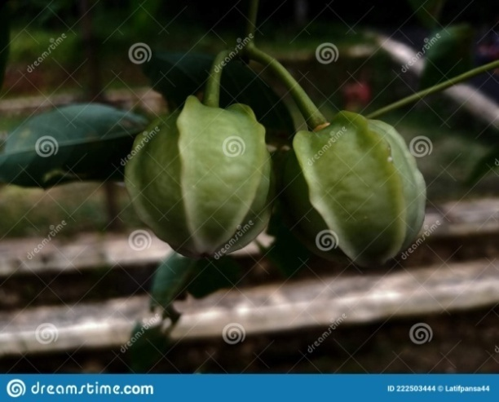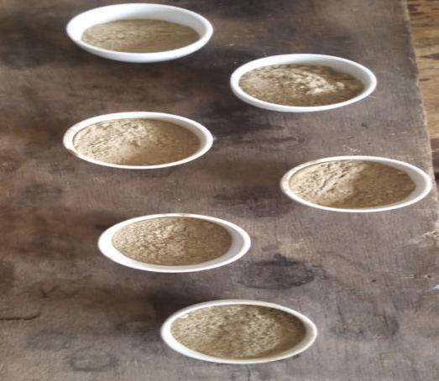
(ii)
(i)
Fig 3.1: Diagram showing (i) Cassava Seed Fruit (ii) Crushed Cassava Seed Shell
3.3.1 PREPARATION OF THE ACID MODIFIED CASSAVA SEED SHELL
50.025g of 125 - 250µm of the ground and sieved sample was soaked in 0.1M H₃PO₄ for 24hrs at room temperature. This was followed by washing the sample severally with distilled water until the pH was neutral and then oven dried at a temperature of 105^{ᵒ}C. The dried sample was weighed to be 30.935g and then kept in a tight container.

3.4 CHARACTERIZATION OF THE ADSORBENTS
The UMCSS and AMCSS were characterized to determine the chemical composition by the use of the Atomic Adsorption Spectrophotometer (AAS). The X-ray diffraction analysis of the adsorbents was determined by the use of the X-ray diffractometer. An FT-IR spectrum of the adsorbents were taken with a Fourier-transform infrared spectrophotometer to give the vibrational frequencies of the lattice present in the UMCSS and AMCSS particles using the KBr pellet method. The Thermal gravimetric analysis was also determined using a TA instrument to check for thermal stability and moisture content. The pore properties and BET surface area of UMCSS and AMCSS were determined through nitrogen adsorption-desorption isotherms while Scanning Electron Microscope (SEM) which is made up of Energy Dispersive X-ray (EDX) was used to access the morphology of the adsorbents.
3.5 ADSORBATE PREPARATION
A laboratory solution of Ni²⁺ was prepared by dissolving 4.05g of NiCl₂.6H₂O in 10ml of deionized water in a beaker and stirred properly with a glass rod to ensure proper dissolution. Thereafter, the 10ml solution was then placed in a 1L Volumetric flask and made up to meniscus mark with deionized water to obtain a stock solution of concentration 1000mg/L of the metal ion. Several lower concentrations of Ni²⁺ solution which include 10, 20, 30, 40 and 50mg/L were then prepared from the stock solution by serial dilution.
3.6 ADSORPTION STUDY
Batch adsorption procedure was done to determine the effect of the initial metal ion concentration, contact time, pH and temperature as described below:
3.6.1 DETERMINATION OF THE EFFECT OF INITIAL METAL CONCENTRATION
0.5g of the Acid Modified Cassava seed shell adsorbent was dissolved in 20ml of each of the concentrations ranging from 10-50mg/L of the serial dilution prepared from the stock solution in 100ml plastic bottles after which the plastics were corked then agitated for 10mins at room temperature in a flask shaker. The solution was then filtered afterwards and the filtrate was taken to the Atomic adsorption spectrophotometer (AAS) for determination of metal ion remaining in the solution.
3.6.2 DETERMINATION OF EFFECT OF CONTACT TIME
0.5g of the Acid Modified Cassava seed shell was placed in five 100ml plastic bottles of which 20ml of metal ion solution of concentration 30mg/L was added to the bottles. The solution was agitated for 10mins after been corked and left to stand at different contact time of 10, 20, 30, 40 and 50 mins. At the end of the given contact time for each of the experiment, the solution was filtered and the concentration of metal ion remaining in the filtrate was determined from the Atomic adsorption spectrophotometer (AAS).
3.6.3 DETERMINATION OF EFFECT OF pH
0.5g of Acid Modified Cassava seed shell was placed in four 100ml plastic bottles of which 20ml of metal ion solution of concentration 50mg/L was added to the bottles by the drop-wise addition of 0.1M HCl or 0.2M NaOH and the pH of each solution was adjusted to pH values of 3, 4, 8 and 9. The solution was agitated for 10mins after which it was filtered and the metal ion concentration remaining in the filtrate was determined from the Atomic adsorption spectrophotometer (AAS).
3.6.4 DETERMINATION OF EFFECT OF TEMPERATURE
0.5g of Acid Modified Cassava seed shell was added to 20ml of metal ion solution of concentration 50mg/L in four 100ml plastic bottles and was corked then placed in a thermo-stated water bath to help regulate the temperature at 300, 303, 313 and 323K. The solution was then filtered and the filtrate taken to the Atomic adsorption spectrophotometer for the determination of metal ion concentration remaining in the solution.

3.7 CALCULATION OF PERCENTAGE REMOVAL AND ADSORPTION CAPACITY
The percentage of metal ions removed and adsorption capacity of the Acid Modified Cassava seed shell for Ni²⁺ ions from the laboratory solution were calculated from the equation given below:
$\%Removal= \frac{100\left(C_{o}-C_{e}\right)}{C_{o}}$ (24)
$q_{e}= \frac{V\left(C_{o}-C_{e}\right)}{m}$ (25)
Where q_{e}(mg/g) is the adsorption capacity, C_{o}(mg/L) is the initial metal ion concentration in solution, C_{e}(mg/L) is the metal ion concentration remaining in the solution at equilibrium, V(L) is the volume of solution used for the adsorption and m(g) is the mass of the adsorbent used.

CHAPTER FOUR
RESULTS AND DISCUSSION
4.1 CHARACTERIZATION OF BIOSORBENTS BY FOURIER-TRANSFORM INFRARED SPECTROSCOPY (FT-IR) ANALYSIS
The FT-IR spectra of Acid Modified Cassava Seed Shell Residue (AMCSSR₅), Acid Modified Cassava Seed Shell (AMCSS) and Unmodified Cassava Seed Shell (UMCSS) were recorded in the range of 4000 – 500cm⁻¹ and are presented in Fig 4.1, 4.2 and 4.3 respectively. The spectra identified the surface functional groups present and also illustrated the changes in biosorbent after phosphoric acid treatment. The change in the adsorption band of –OH from 3423.62cm⁻¹ to 3446.70cm⁻¹, 1633.87cm⁻¹ to 1639.91cm⁻¹ indicated that modification was noticed on the positions. The Acid Modified Cassava Seed Shell at concentration of 50mg/L (AMCSSR₅) showed a new band of adsorption at 2362.63cm⁻¹ corresponding to the –OH vibration which was absent in the AMCSS and UMCSS indicating the presence of free OH sites on the AMCSSR₅. The spectrum of UMCSS showed absorptions at 2926.34cm⁻¹ and 3423.6cm-1 which corresponds to the inner surface –OH stretching vibration. The band which appeared at 1424cm⁻¹ corresponds to the alkyl symmetric deformation whereas that of medium intensity at 1639.91cm⁻¹ in the spectrum of AMCSS appeared due to C=O stretching vibrations. It can be observed therefore, that after the acid treatment, the absorption bands appear at similar positions with less intensity. The FT-IR spectra revealed the carboxylic and alcoholic groups as the major sites for binding of the positively charged ions onto AMCSS.
Fig. 4.1: FT-IR Spectrum of Acid Modified Cassava Seed Shell (AMCSS)

Fig. 4.2: FT-IR Spectrum of Acid Modified Cassava Seed Shell Residue (AMCSSR5)

Fig. 4.3: FT-IR Spectrum of Unmodified Cassava Seed Shell (UMCSS)

4.2 THE BRANAUER-EMMETH-TELLER (BET) SURFACE AREA OF THE ADSORBENT
BET theory aims to explain the physical desorption of gas molecules on a solid surface and serves as the basis for an important analytic technique for the measurement of the specific surface area of materials and pore size distribution. The BET diagram of UMCSS and AMCSS are shown in Fig. 4.4 and Fig. 4.5 respectively. The BET surface area increased from 182.520m²/g in UMCSS to 1480.650m²/g in AMCSS showing an increased pore size for better adsorptivity.

Fig. 4.4 Branauer-Emmeth-Teller Diagram For UMCSS
Fig. 4.5: Branauer-Emmeth-Teller Diagram For AMCSS

4.3 THERMAL GRAVIMETRIC ANALYSIS (TGA) OF THE ADSORBENT
The TGA pattern of AMCSS and UMCSS are shown in Fig. 4.6 and 4.7 respectively. TGA is used for the evaluation of thermal stability of a material. It can also be used for materials characteristic deposition patterns. Fig. 4.6 shows the thermal gravimetric analysis (TGA) of the acid modified cassava seed shell (AMCSS). On the TGA profile, the initial step shows a weight loss of 2% in the temperature range of 90^{ᵒ}C to 194^{ᵒ}C, which might have resulted from the release of moisture and volatile matter. Afterwards, a second step was obtained between 194^{ᵒ}C and 340^{ᵒ}C, corresponding to the highest weight loss of 77%. This step is related to hemicelluloses and cellulose decomposition, as well as loss of the remaining adsorbed water (Yang et al., 2007). The third step involved a gradual loss in weight at temperature above 340^{ᵒ}C, which may be attributed to decomposition of cellulose and continued up to 600^{ᵒ}C, due to the decomposition of lignin with weight loss of 5%.
On the other hand, Fig. 4.7 shows the thermal gravimetric analysis (TGA) of the unmodified cassava seed shell (UMCSS). At first, there was a weight loss of 7%, which was attributed to the release of moisture content and volatile matter at a temperature range of 99^{ᵒ}C to 194^{ᵒ}C. The second decomposition stage of the profile shows a weight loss of 82% at a temperature range of 194^{ᵒ}C to 358^{ᵒ}C due to the decomposition of hemicelluloses and cellulose. The final stage of the profile exhibited weight loss of 5% at a temperature range of 358^{ᵒ}C to 600^{ᵒ}C resulted from the decomposition of lignin. AMCSS and UMCSS were found to be thermally stable up to temperature of 200^{ᵒ}C and 250^{ᵒ}C respectively.
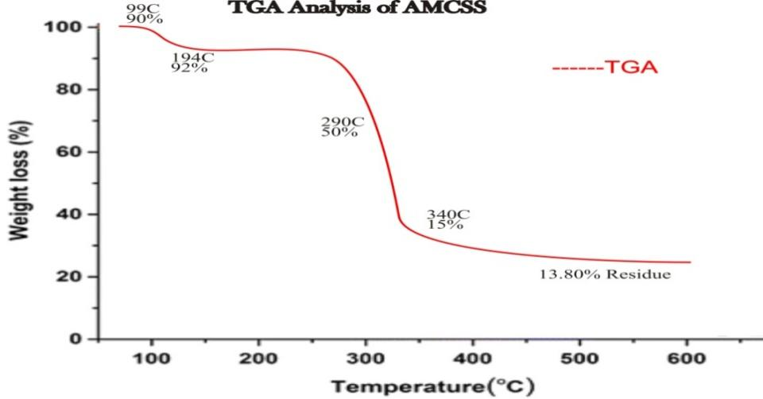
Fig. 4.6 Thermal Gravimetric Analysis For AMCSS
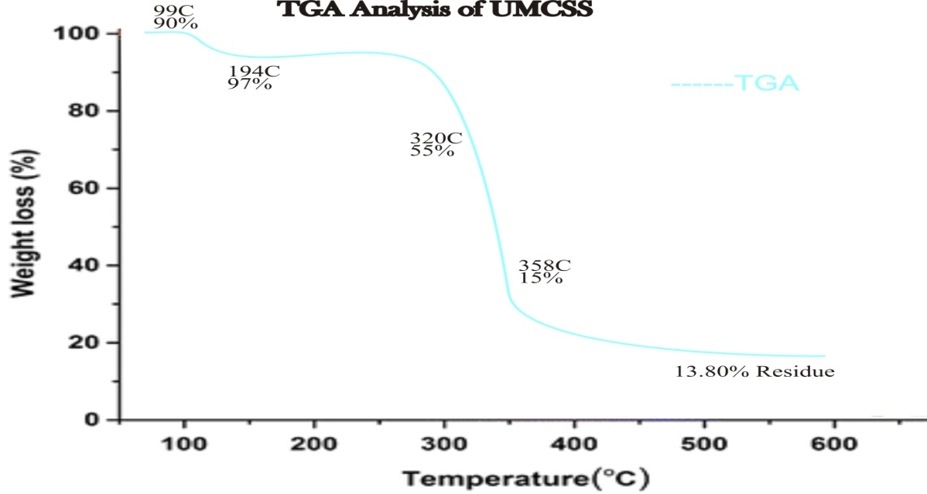
Fig. 4.7 Thermal Gravimetric Analysis For UMCSS

4.4 SCANNING ELECTRON MICROSCOPY (SEM)
The SEM analysis of UMCSS, AMCSS and AMCSSR₅ was taken in order to examine their surface morphology and is presented in Fig. 4.8, 4.9 and 4.10 respectively. The porous nature of the adsorbents was revealed by the SEM images and an increase in surface porosity as observed on AMCSS was obtained.
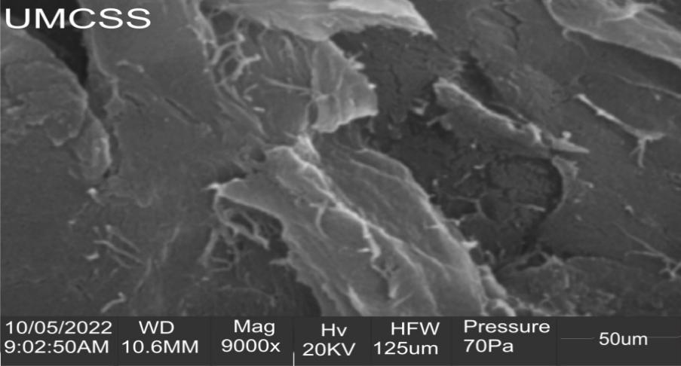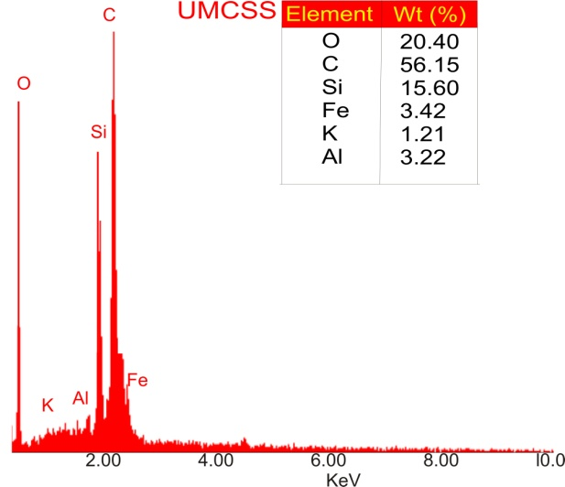
Fig. 4.8: Scanning Electron Microscopy (SEM/EDX) For UMCSS
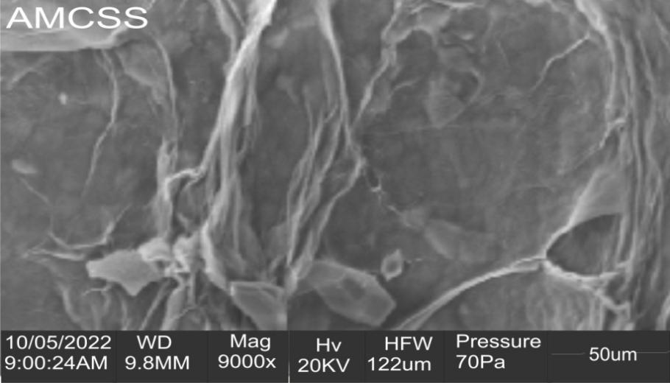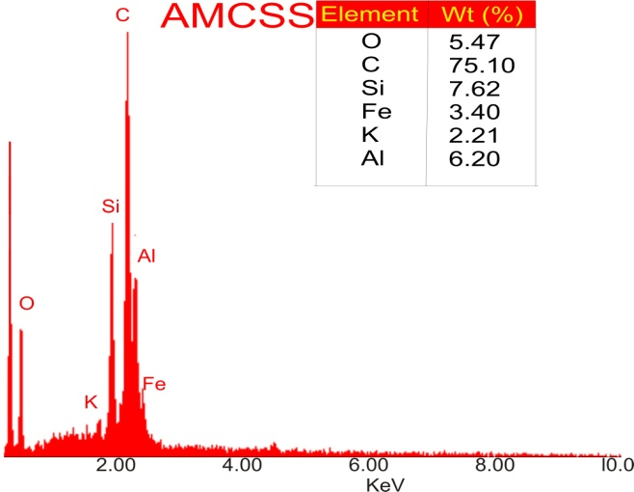
Fig. 4.9: Scanning Electron Microscopy (SEM/EDX) For AMCSS
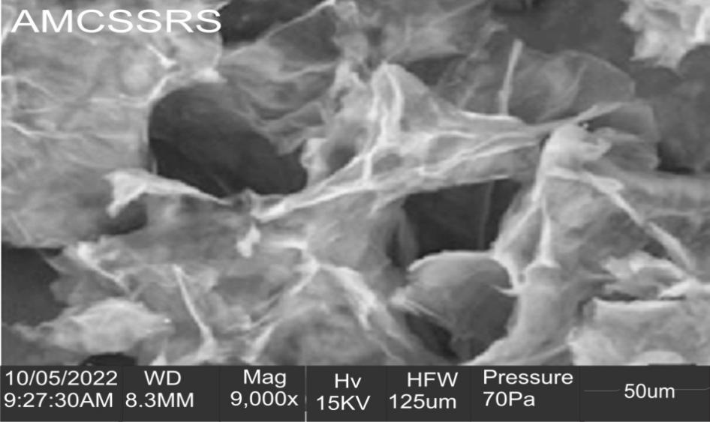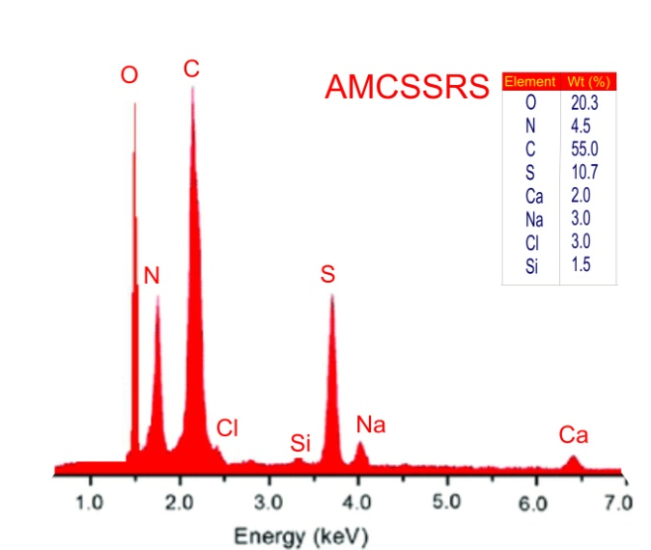
Fig. 4.10: Scanning Electron Microscopy (SEM/EDX) For AMCSSR₅

4.5 EFFECT OF INITIAL METAL ION CONCENTRATION
The rate at which metal ions are adsorbed from their solution onto the surface of the adsorbents is a function of the initial metal ion concentration, thus, making it an important factor for an effective sorption (Emam et al., 2016). It was observed that the percentage removal of metal ions decreased with increase in the initial metal ion concentration from 10 to 50mg/L after which it became fairly stable as shown in Fig. 11. The decrease in adsorption is due to the adsorbent have a fixed number of active sites and at higher concentrations, the active sites became saturated (Dawodu and Akpomie, 2014). Also, the adsorption capacity of the adsorbent increased with increase in Ni(II) ion concentration due to increasing gradient as shown in Fig. 4.12 which counters the insulation to mass exchange of the metal ions between the adsorbate and the adsorbent specie (Emam et al., 2016).

Fig. 4.11: The Effect of Initial Metal Ion Concentration on the Percentage Removal of Ni²⁺ from Solutions onto AMCSS

Fig. 4.12: The Effect of Initial Metal Ion Concentration on the Adsorption Capacity of Ni²⁺ from Solutions onto AMCSS

4.6 ADSORPTION ISOTHERMAL STUDY
4.6.1 LANGMUIR ISOTHERM
The values of the constants, q_{L} and K_{L} can be determined from the slope and intercept of the linear plot of C_{e}/q_{e} against C_{e}. The Langmuir Isotherm plot for the adsorption of Ni²⁺ onto Acid Modified Cassava Seed Shell is shown in Fig. 4.13 from Table 4.1. The regression coefficient R² of the metal ion gave a high value of 0.904 indicating a good fit of the monolayer Langmuir isotherm to the adsorption of the metal ions onto AMCSS.
Adsorption is said to be irreversible (R_{L} = 0), favourable (0 < R_{L}< 1), linear (R_{L} = 1) or non-favourable (R_{L}> 1). For the initial metal ion concentration from 7.8974 to 36.5897mg/L used in this study, the values of R_{L} ranged from 0.15 to 0.038 for Ni²⁺ indicating a favourable adsorption of the metal ions on AMCSS.

Fig. 4.13: Langmuir Isotherm Model for Sorption of Ni²⁺ Onto AMCSS

4.6.2 FREUNDLICH ISOTHERM
The Freundlich constant, K_{F} calculated for AMCSS was 0.108 with the value of n given as 2.05 which is greater than one, indicating that the adsorption was favourable and the process is physisorption (Abshirini et al., 2019). As can be seen from the plots in Fig. 4.14 and Table 4.1, the value of the correlation coefficient (R² = 0.937) of the AMCSS is way higher than that of Langmuir isotherm plot indicating that the Freundlich isotherm best describes the adsorption of Ni²⁺ onto AMCSS.

Fig. 4.14: Freundlich Isotherm Model for Sorption of Ni²⁺ onto AMCSS
4.6.3 TEMKIN ISOTHERM
The constants A and B were determined from the slope and intercept of the linear plot of qe against LnC_{e} as seen in Fig. 4.15. The value of the regression coefficient gave 0.900 indicating that the adhesion of metal ions on the surface of AMCSS involved less energy as a result of high surface coverage. The low value of B (0.154J/mol/K) in this study indicated a weak interaction between the adsorbent and adsorbate supporting a mechanism of ion exchange.

Fig. 4.15: Temkin Isotherm Model for Sorption of Ni²⁺ onto AMCSS
4.6.4 FLORY-HUGGINS ISOTHERM
The Flory-Huggins constant, K_{FH} was determined from the linear representations of the function Log(θ/C_{o}) against Log(1-θ) as seen in Fig. 4.16. In addition, the Gibb’s energy $∆G°$ was determined from the value of the K_{FH}, calculated to give -1.883KJ/mol indicating the reaction to be exothermic.

Fig. 4.16: Flory-Huggins Isotherm Model for Sorption of Ni²⁺ onto AMCSS

4.6.5 DUBININ-KAGANER-RADUSHKEVICH ISOTHERM
From the linear plot of Lnq_{e} against $ε$² as seen in Fig. 4.17, K_{DR} and the mean free energy E are determined giving values of 0.079 and 2.156kJ/mol respectively. The value of E being less than 8kJ/mol indicates that the adsorption process is physisorption.

Fig. 4.17: Dubinin-Kaganer-Radushkevich Isotherm Model for Sorption of Ni²⁺ onto AMCSS
Table 4.1: Langmuir, Freundlich, Temkin, Dubinin-Radushkevich and Flory-Huggins Model Parameters for the Adsorption of Ni(II) ion onto AMCSS
ISOTHERM MODELS | AMCSS
Langmuir Model
q_{L} (mg/g) | 0.1016
K_{L} (L/mg) | 0.6925
R² | 0.904
Freundlich Model
K_{F} (L/g) | 0.108
n | 2.05
R² | 0.937
Temkin Model
B_{T} (J/mol/K) | 0.154
A_{T} (L/g) | 1
R² | 0.900
Dubinin-Radushkevich Model
K_{DR} | 0.079
q_{max} | 0.453
E | 2.516
R² | 0.830
Flory-Huggins Model
$∆G°$ (kJ/mol) | -1.883
R² | 0.936
n | -3.853
K_{FH} | 2.138 x 10⁻³

4.7 EFFECT OF CONTACT TIME
The effect of contact time on the adsorption of Ni²⁺ ion onto AMCSS is shown in Fig. 4.18. An initial decrease in percentage removal with increase in contact time from 10 to 50 mins was observed and the adsorption became fairly stable with time. Equilibrium removal was achieved at 30mins, after which further increase in contact time did not result in any significant adsorption.

Fig. 4.18: The Effect of Contact Time on the Percentage Removal of Ni²⁺ from Solutions onto AMCSS

4.8 ADSORPTION KINETICS STUDY
The kinetic studies of pseudo-first order, pseudo-second order, intraparticle diffusion and liquid-film diffusion plots are shown in Figs. 4.19, 4.20, 4.21 and 4.22 respectively. The evaluated parameters from these kinetic models are well stated in Table 4.2. From the regression coefficient (R²), it was observed that the adsorption kinetics data were well described by Pseudo-Second order kinetics having R² approximate to 1 (Fig. 4.20). Looking at Table 4.2, we would see that the q_{e} (calc.) value is close to the q_{e} (exp.) value indicating the earlier claim that the adsorption kinetics follows the pseudo-second order plot.

Fig. 4.19: Pseudo-First Order Kinetics Plot for Sorption of Ni²⁺ Onto AMCSS

Fig. 4.20: Pseudo-Second Order Kinetics Plot for Sorption of Ni²⁺ Onto AMCSS

Fig. 4.21: Intraparticle Diffusion Kinetics Plot for Sorption of Ni²⁺ Onto AMCSS

Fig. 4.22: Liquid Film Diffusion Kinetics Plot for Sorption of Ni²⁺ Onto AMCSS

Table 4.2: Comparison of the Kinetic Model on the Adsorption Of Ni²⁺ from Solution onto AMCSS
KINETIC MODEL | AMCSS
q_{e} (exp) | 0.3582
Pseudo-first order
K₁ (min⁻¹) | -0.034
qe (mg/g) | 4.038 X 10⁻³
R² | 0.281
Pseudo-second order
K₂ (min⁻¹) | 0.295
qe (mg/g) | 0.3287
R² | 0.716
h₂ | 0.032
Intraparticle diffusion
K_{d} (mg/gmin^{1/2}) | 0.032
C | 0.073
R² | 0.351
Liquid film diffusion
K_{fd} | 0.054
P | -3.583
R² | 0.160

4.9 EFFECT OF TEMPERATURE
The influence of solution temperature on the adsorption of Ni(II) ion from solution by AMCSS is shown in Fig. 4.23. An increase in adsorption of Ni(II) ion with increase in temperature from 300 – 323K was observed. The increase may be due to a greater kinetic energy acquired by the metal ions to overcome the energy barrier and the creation of more active sites on the adsorbent due to dissociation of some of the surface components on AMCSS (Li et al., 2011).

Fig. 4.23: The Effect of Temperature on the Percentage Removal of Ni²⁺ from Solutions onto AMCSS

4.10 ADSORPTION THERMODYNAMICS STUDY
An increase in the adsorption of the metal ion with increase in temperature was obtained. The values of the thermodynamic parameters obtained are given in Table 4.3. It was observed that positive $∆$G^{ᵒ} values were obtained at 300, 303, 313 and 323K for Ni(II) ion sorption on AMCSS which indicated a non-spontaneous process. Also, the changes in$∆$G^{ᵒ} decreased with increase in temperature meaning that the higher temperature does not favour the adsorption process making it non-spontaneous.
Positive values of $∆Sᵒ$ obtained indicated an increase in randomness of Ni(II) ions in solution and its interaction with the AMCSS. Positive $∆H$ values obtained suggested an endothermic process which supported the increase in sorption with temperature obtained in Fig. 4.26 and the early claim that the process of adsorption is physical in nature.

Table 4.3: Thermodynamic Parameters for the Adsorption of Ni(II) ion onto AMCSS
ADSORBENT | TEMP. (K) | $∆$G^{ᵒ}(kJ/mol) | $$∆Sᵒ(J/molK)$$ | $∆Hᵒ$ (kJ/mol)
AMCSS | 300 | +7142.8 | +12.344 | +15.802
AMCSS | 303 | +6366.6 | +12.344 | +15.802
AMCSS | 313 | +6813.7 | +12.344 | +15.802
AMCSS | 323 | +5960.3 | +12.344 | +15.802

4.11 EFFECT OF pH
The initial pH of a solution is an important controlling parameter in adsorption process and metal ion removal usually increases with increase in pH. The pH of a solution affects the ionization degree of the adsorbate and the surface property of the adsorbent (Das and Mondal, 2011). The effect of initial pH of a solution on the percentage removal of Ni(II) ions from solution onto AMCSS is shown in Fig. 4.24. An increase in adsorption of the metal ion with increase in pH was obtained. Significant adsorption of the metal ion was achieved at pH values of 8 to 9. The low adsorption recorded at low pH values is due to the saturation of the active sites of AMCSS with hydrogen ions. Also, the increase in Ni(II) ion removal with increase in pH can be explained on the basis of the decrease in competition between protons and metal ions for the active sites and by the decrease in positive surface charges with which results in a lower electrostatic repulsion between the surface and the metal ions before ion exchange (Taffarel and Rubio, 2009).

Fig. 4.24: The Effect of pH on the Percentage Removal of Ni²⁺ from Solutions onto AMCSS

CHAPTER FIVE
CONCLUSION AND RECOMMENDATION
5.1 CONCLUSION
The result of the present study showed that the Acid modification of the Cassava Seed Shell enhanced its adsorption capacity for Ni(II) ion. The FT-IR spectra of AMCSS revealed the existence of certain functional groups responsible for binding of the Ni(II) ions from solution. SEM morphology indicated an increase in the porous nature of the Acid Modified adsorbent (AMCSS) when compared to the unmodified form (UMCSS). This porous nature enhances metal ion adsorption on AMCSS. The heterogeneous nature of AMCSS was revealed by the good fit of the data to the Freundlich model while thermodynamics studies revealed an endothermic, non-spontaneous and physical adsorption process. These results indicates the potential of AMCSS as a low cost adsorbent for the removal of Ni(II) ion from solution.
5.2 RECOMMENDATION
This research study shows that AMCSS has the ability to remove Ni(II) and other harmful substances from aqueous solution. It is therefore recommended that industries in Nigeria should practically begin to apply these low cost agricultural waste materials for removal of heavy metals so as to avert the health problem derived from heavy metals pollution.

REFERENCES
Aajish, L. G., Thirumal, J., and Thirumal, T. J. (2014). Preparation and Characterization of Activated Carbon Derived from Waste Materials and Its Application in the Removal of Fluoride from Ground Water IOS3. J.Env. Sci. Tox. Food Tech., Vol. 8, no 5, pp. 28-33
Abshirini, Y., Forouton, R., and Esmaeili, H. (2019). Cr(VI) Removal from Aqueous Solution Using Activated Carbon Prepared from Ziziphis spina-christi Leaf. Mater. Res. Express., 6(4): 545-607
Ahluwalia, S. S., and Goyal, D. (2007). Microbial and Plant Derived Biomass for Removal of Heavy Metals from Wastewater. Bioresour. Technol., 98: 2243-2257
Akinhanmi, T. F., Ofudje, E. A., Adeogun, A. T., Aina, P., and Joseph, M. (2020). Orange Peel as Low-Cost Adsorbent in the Elimination of Cd(II) ion: Kinetics, Isotherm, Thermodynamic and Optimization Evaluations. Bio. Res., 7: 34-40
Akpomie, K. G., and Dawodu, F. A. (2014). Efficient Abstraction of Nickel and Mn(II) ions from Solution unto an Alkaline Modified Montmonillonite. J. Taibah Uni. Sci.
Akpomie, K. G., Odewole, O. A., Ibeji, C. U., Okay, O. D. and Agboola, I. I. (2017). Enhanced Sorption of Trivalent Chromium Unto Novel Cassava Peel Modified Kaolinite Clay. Der Pharma Chemica, 9(5): 48-55
Al-Ghouti, M. A., and Da’ana, D. A. (2020). Guidelines for the Use and Interpretation of Adsorption Isotherm Models: A Review. J. Haz. Mat.,393:122-383
Ali, I., Asim, M., Khan, T. A. (2012). Low-Cost Adsorbent for the Removal of Organic Pollutants from Wastewater. J. Env. Manag., Vol. 113, pp.170-183
Amin, M. T., Alasba, A. A., and Shatiq, M. (2021). “Comparative Removal of Lead and Nickel ions Onto Nanofibrous Sheet of Activated Polyacrylonitrile in Batch Adsorption and Application of Conventional Kinetic and Isotherm Models”. Membranes, Vol. 11, pp.1-16
Artioli, Y. (2008). Adsorption. Encyclopedia of Ecology.
Arunkumal, C., Perumal, R., Lakshmi, N. S., and Arunkumal, J. (2014). Use of Corn Cobs as Low-Cost Adsorbent for the Removal of Nickel(II) from Aqueous Solutions. Int. J. Adv. Biotech. Res. (ITBR). Vol. 5(3): 325-330
Ayawei, N., Ebelegi, A. N., and Wankasi, D. (2017). Modelling and Interpretation of Adsorption Isotherms. Journal of Chemistry, Vol. 3, pp.39-81
Badmus, M. A. O., Audu, T. O. K., and Anyata, B. U. (2007). Removal of Lead ions from Industrial Wastewaters by Activated Carbon prepared from Periwinkle Shells. Turkish. J. Eng. Env. Sci., 31: 251-263
Bolis, V. (2013). Fundamentals in Adsorption at the Solid-Gas Interface: Concepts and Thermodynamics, Calorimetry and Thermal Methods in Catalysis. Springer Series in Materials Science, 154: 1-50
Boparai, H. K., Joseph, M., and O'Caroll, D. (2011). Cadmium(II) Removal by Nano Zerovalent Iron: Surface Analysis, Effects of Solution Chemistry and Surface Complexation Modelling. Environ. Sci. Pollut. Res.,20: 6210-6221
Celebi, O. (2007). A Radio tracer Study of The Adsorption Behavior of Aqueous Ba²⁺ Ions on Nanoparticles of Zerovalent Iron. Journal of Hazardous Materials, 148(3):761-767
Dabrowski, A. (2001). Adsorption –From Theory to Practice. Adv. Colloid Interface Sci.,93: 135-224
Dalia, M. G., Cukrowska, E. M., and Tutu, H. (2012). Phosphonated Cross-linked Polyethylene mine for Selective Removal of Uranium ions from Aqueous Solutions. Water Sci. Tech.
Das, B., and Mondal, N. K. (2011). Calcareous Soil as a New Adsorbent to Remove Lead from Aqueous Solution: Equilibrium, Kinetic and Thermodynamics Study. Univer. J. Environ. Res. Technol., 1(4): 515-530
David, M. K., Okoro, U. C., Akpomie, K. G., Okey, C., and Oluwasola, H. O. (2020). Thermal and Hydrothermal Alkaline Modification of Kaolin for the Adsorptive Removal of Lead(II) ions from Aqueous Solutions. SN. App. Sci., 2:11-34
Dawodu, F. A., and Akpomie, K. G. (2014). Simultaneous Adsorption of Ni(II) and Mn(II) Ions From Aqueous Solution Onto a Nigerian Kaolinite Clay. J. Mater. Res. Technol., 3(2): 129-141
Ejikeme, P. M., Okoye, A. I., and Onukwuli, O. D. (2011). Kinetics and Isotherm Studies of Cu²⁺ and Pb²⁺ Ions Removal from Simulated Wastewater by Gambeya albida Seed Shell Activated Carbon. The African Review of Physics, 6:17
El-Said, A., Badawy, N., and Garamon, S. (2018). Adsorption of Heavy Metal Ions from Aqueous Solutions Onto Rice Husk Ash Low Cost Adsorbent. J. Environ. Anal. Toxicol, 8:1
Emam, A. A., Ismail, L., and Abdulkhalek, M. (2016). Adsorption Study of Some Heavy Metal Ions on Modified Kaolinite Clay. Int. J. Adv. Eng. Technol., 3(7): 152-163
Eze, S. I., Abugu, H. O., Odewole, O. A., Ukwueze, N. N., and Alum, L. O. (2021). Thermal and Chemical Pretreatment of Cassia siberian Seed Husk as Biosorbent for Pb²⁺ Removal from Aqueous Solution. Journal of Desalination and Water Treatment, 226: 223-241
Fourantan, R. (2019). Characteristics and Performance of Cd, Ni and Pb Bio-Adsorption Using Callinectessapidus Biomass: Real Wastewater Treatment. Env. Sci. Pollut. Res., 26(7): 6336-6347
Gautam, R. K. (2014). Biomass-Derived Biosorbents for Metal Ions Sequestration: Adsorbent Modification and Activation Methods and Adsorbent Regeneration. J. Env. Chem. Eng., 2(1): 239-259
Ho, S., and McKay, G. (1998). Sorption of Dye from Aqueous Solution by Peat. Chem. Eng. J.,70: 115-124
Hoyos-Sanchez, M. C., Cordoba-Pacheco, A. C., Rodriguez-Herrera, L. F., and Uribe-Kaffure, R. (2017). Removal of Cd(II) ion from Aqueous Media by Adsorption Onto Chemically and Thermally Treated Rice Husk. J. Chem., Vol. 1:8
Igwe, J. and Abia, A. (2007). Equilibrium Sorption Isotherm Studies of Cd(II), Pb(II) and Zn(II) Ions Detoxification from Wastewater Using Unmodified and EDTA-Modified Maize Husk. Electronic Journal of Biotechnology, 10(4): 15
Jiang, H. (2019). Imaging Covalent Bond Formation by H Atom Scattering from Graphene. Science, 364(64): 379-382
Kadhim, Z. N. (2016). Using of Isolated Hydroxyapatite from Sheep Bones to Remove Lead (II) From Aqueous Solution and Studying the Thermodynamics and Adsorption Isotherm. 4: 149-160
Karagoz, S. (2008). Activated Carbons from Waste Biomass by Sulphuric Acid Activation and Their Use on Methylene Blue Adsorption. Biores. Tech., 99(14): 6214-6222
Kausar, A., Bharti, H. N., and Mackinnon, G. (2013). Equilibrium, Kinetic and Thermodynamic Studies on the Removal of U(VI) by Low-Cost Agricultural Waste: Colloids and Surfaces. Biointerfaces, 111:124-133
Kinhikar, V. R. (2012). Removal of Nickel(II) from Aqueous Solutions by Adsorption with Granular Activated Carbon (GAC). Res. J. Chem. Sci., Vol. 2, pp.6-11
Li, Y., Xia, B., Zhao, Q., Liu, F., Zhang, P., and Du, J. (2011). Removal of Copper Ions from Aqueous Solution by Calcium Alginate Immobilized Kaolin. J. Environ. Sci., 23(3): 404-411
Liakos, E. V., Mine, M., Lambropoulou, D. A., Bikiaris, D. N., and Kyzas, G. Z. (2021). Adsorption Evaluation for the Removal of Nickel, Mercury and Barium ions from Single Component and Mixtures of Aqueous Solutions by Using An Optimized Biobased Chitosan Derivative. Polymers, Vol. 13, pp.1-20
Mervette, E. B., and Abdul-Moneim, M. A. (2014). “Adsorption Kinetics of Nickel(II) Onto Activated Carbon Prepared from Natural Adsorbent Rice Husk”. Int. J. Tech. Enhance. Eng. Res., Vol 2, pp.145-148
Miedaner, M., Weerasooriya, R., and Tobschall, H. (2006). pK Modelling Strategies for the Adsorption of Some Trace Elements onto Gibbsite. Interface Science and Technology, pp.469-490
Mohammad, A., and Bahreini, Z. (2010). Preparation of Carbonaceous Adsorbent from Plant of Calotropisgigantea by Thermo-Chemical Activation Process and Its Adsorption Behavior for Removal of Methylene Blue. World App. Sci. J., Vol. 11, pp.263-268
Muna, A. K., Mishra, G. K., Rai, P. K., Rajagopal, C., and Nagar, P. N. (2005). Removal of Heavy Metal ions from Aqueous Solution Using Carbon Aerogel as an Adsorbent. J. Hazard. Mater.,122(1-2): 161-170
Murai, S. (1998). Removal of Pthalic Acid and Esters from Aqueous Solution by Inclusion and Adsorption on B-Cyclodextrin. Env. Sci. Tech., 32(6): 782-787
Nechifor, G. (2015). Comparative Study of Temkin and Flory-Huggins Isotherms for Adsorption of Phosphate Anion on Membranes. Sci. Bull. B., 77(2): 63-72
Olugbenga, S. P., Kayode, A. A., Olayinka, U. B., and Ibrahim, O. L. (2014). “Sequestering Nickel(II) ions from Aqueous Solutions Using Various Adsorbents”. J. Analyt. Env. Chem., Vol. 15, pp.1-7
Orjoke, N. M., Okoro, U. S., Igwe, C. N., and Ajah, U. N. (2015). Synthesis and Characterization of Zeolite and Its Application in Adsorption of Nickel from Aqueous Solutions. J. Pharm. Chem. Biol. Sci., 3(4): 592-600
Piccin, J. S., Dotto, G. L., and Pinto, L. A. (2011). Adsorption Isotherms and Thermo-Chemical Data of FD & C RED n° 40 Binding by Chitosan. Brazilian Journal of Chemical Engineering, 28(2): 295-304
Sims, R. A., Harmer, S. L., and Quinton, J. S. (2019). The Role of Physisorption and Chemisorption in the Oscillatory Adsorption of Organosilanes on Aluminum Oxide. Polymers, 11(3): 410
Sugamaran, P., Priya, S. V., Ravichandran, P. and Seshadri, S. (2012). Production and Characterization of Activated Carbon from Banana Empty Fruit Branch and Delonixregia Fruit Pod. J. Sus. Energy Env., Vol. 3, pp.125-132
Taffarel, S. R., and Rubio, J. (2009). Removal of Mn(II) Ions by Adsorption onto Natural and Activated Chilean Zeolite. Min. Eng., 22: 336-430
Uchechukwu, S., and Azubuike, O. (2012). Sorption Studies on the use of African breadfruit (Treculia africana) seed hull as adsorbent for the removal of Cu²⁺, Cd²⁺ and Pb²⁺ from aqueous solutions. American Journal of Physical Chemistry, 1(1): 11-21
Umpleby, R. (2001). Application of the Freundlich Adsorption Isotherm in the Characterization of Molecularly Imprinted Polymers. Analytics Chimica Acta, 435: 35-42
Wang, J., and Guo, X. (2020). Adsorption Isotherm Models: Classification, Physical meaning, Application and Solving Method, Chemosphere. 258: 127-279
Wu, Y. (2017). The Removal of Methyl Orange by Periphytic Biofilms: Equilibrium and Kinetic Modelling. Boston, pp.367-387
Yan, X. F. (2017). An Adsorption Isotherm Model for Adsorption Performance of Silver-Loaded Activated Carbon. Thermal Science, 21(4): 1645-1649
Yang, H., Yan, R., Chen, H., Lee, D., and Zheng, C. (2007). Characteristics of Hemicellulose, Cellulose and Lignin Pyrolysis. Fuel, Vol. 86, pp.1781-1788

